SCORM Driver Quickstart Guide
This guide will show you how to get started using SCORM Driver, free for non-commercial use. It kind of applies to paying users, as well.

SCORM Driver is free for
non-commercial use.
Learn More
1. PICK VERSION | 2. HYPERLINK "http://scorm.com/scorm-solved/scorm-driver/scorm-driver-quickstart-guide-2-update-titles"UPDATE TITLES | 3. HYPERLINK "http://scorm.com/scorm-solved/scorm-driver/scorm-driver-quickstart-guide-3-insert-content" INSERT CONTENT | 4. MATCH NAMES
5. ADD EXTRAS | 6. ZIP IT!
1. Pick a version
SCORM Driver works across the board with almost any e-learning specification. In order to make it easy for you to use Driver for free, we ask that you pick which specification you want to use. The only place to download SCORM Driver is on the “Add Content” page of SCORM Cloud. (A SCORM Cloud trial is free, and you can sign up here.)
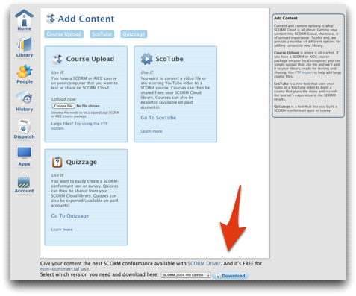
Which specification do I need?
That depends on your LMS. Find out what specs your LMS accepts, and then match that spec to the download of SCORM Driver. It’s most likely SCORM or AICC. If in doubt, choose SCORM 1.2.
Here are the options that you have:
- Tin Can API
- SCORM 1.2
- SCORM 2004 3rd Edition
- SCORM 2004 4th Edition
- AICC
What am I downloading?
When you download Driver for whatever specification you need, you’ll be downloading a zip file that contains a template for your SCORM/Tin Can/AICC package. To use Driver, all you need to do is change some of the template to reflect your content, insert your content, and then let our Driver javascript do the heavy lifting for you.
Can I still try it if I don’t have a course to test with?
Yep. We created a very basic sample course that has zero SCORM/Tin Can/AICC conformance. If you’d like to experiment with making it conformant via this Quickstart Guide, you can download it here.
If you want to see how this sample course looks after it has become SCORM/Tin Can/AICC conformant with SCORM Driver, you can download the appropriate files here:
- Sample HYPERLINK "http://scorm.com/wp-content/assets/driver-free-sample-courses/SCORM-Driver-with-sample-course-Tin-Can.zip" Course – Tin Can API
- Sample HYPERLINK "http://scorm.com/wp-content/assets/driver-free-sample-courses/SCORM-Driver-with-sample-course-AICC.zip" Course – AICC
- Sample HYPERLINK "http://scorm.com/wp-content/assets/driver-free-sample-courses/SCORM-Driver-with-sample-course-SCORM12.zip" Course – SCORM 1.2
- Sample HYPERLINK "http://scorm.com/wp-content/assets/driver-free-sample-courses/SCORM-Driver-with-sample-course-SCORM2004-3rd.zip" Course – SCORM 2004 3rd Edition
- Sample HYPERLINK "http://scorm.com/wp-content/assets/driver-free-sample-courses/SCORM-Driver-with-sample-course-SCORM2004-4th.zip" Course – SCORM 2004 4th Edition

2. Update Titles and Paths
In the root folder of the SCORM Driver package that you just downloaded, you’ll see some files. They’ll be different depending on what specification you chose, but this step is similar for all specs.
Software you might need
You’ll need a text editor to edit most of the files that you’ll be editing. Some text editing programs will attempt to display the files as webpages instead of text, so for the purposes of this guide we’ll be using TextWrangler for Mac (it’s free.) Don’t use TextEdit for Mac, it won’t work. If you’re on a Windows machine, WordPad (no download required) is the text editor that you want to use.
First step for all versions of SCORM
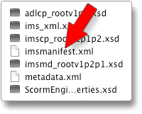For SCORM, you should see a file in the root folder called imsmanifest.xml. You can ignore all other files at this time, and open up imsmanifest.xml with your favorite text editor (TextWrangler or WordPad).
You’ll see the code contained in this file, but we’re only concerned with two small bits — the text that’s in between the two “Title” tags.
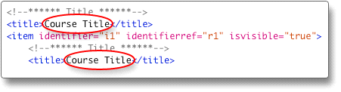
Just change the “Titles” that you see circled here to the name of your content as you want it to be displayed in your LMS. Re-save the imsmanifest.xml file after you’ve made your changes, and you’re done with this step for SCORM.
You’ll also want to update the “Resources” list inside the imsmanifest.xml file. This is basically any file or asset that is used in your course. It includes files that are used by SCORM Driver as well as HTML, images, movies, Flash or any other assets used in your course. If you downloaded our sample HYPERLINK "http://cdn2.scorm.com/wp-content/assets/driver-free-sample-courses/How-to-import-a-course-into-SCORM-Cloud.zip"course, then the Resources section of your imsmanifest file will look like this:
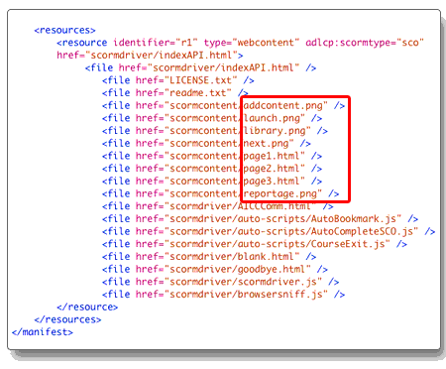
You want to replace the highlighted section in the imsmanifest file with the assets that make up your course. If it’s not highlighted in the image above, leave it as it is. Save the imsmanifest.xml file, and you’re done with the this part.
First steps for AICC
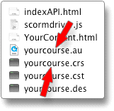The process is similar if you’ve chosen AICC as your specification. At this point, you can ignore all files in the root directory except for yourcourse.au and yourcourse.crs. Open these files with your favorite text editor (TextWrangler, WordPad, etc.) and you’ll change just a few lines of text in the files.
yourcourse.au
If your content and your LMS are all on the same domain (cloud.scorm.com for example,) you can skip editing this file and go right down to editing yourcourse.crs. If your content is being hosted on a different domain than your LMS (cross domain), then you’ll need to replace “scormdriver/indexAPI.html” to “http://YourDomainName.com/YourSubFolder/indexAPI.html”. Re-save this file, and move on to the yourcourse.crs file.
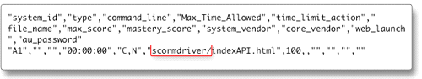
yourcourse.crs
This file is the easiest of all. Make sure it’s open in your text editor, change the “Title” on the 5th line of the file to the title of your course, re-save the file, and you’re done.
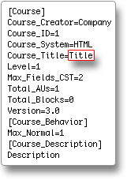
First steps for Tin Can API
After you’ve downloaded SCORM Driver with Tin Can API support, you’ll need to modify two files that are found in the root directory of the download.
tincan.xml
The first is “tincan.xml”. Open the file in your text editor, and change the following lines:
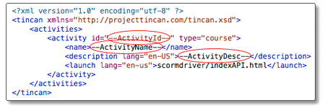
Here’s what to modify in tincan.xml:
- --ActivityID-- : This is the object of the Tin Can statement. It’s usually a URL. You can use whatever you want here, just make it something that makes your activity uniquely identifiable.
- --ActivityName-- : Replace this with the title of your course or activity.
- --ActivityDesc-- : Replace this with a very brief description of your activity.
After you’ve made your modifications, save your file.
tc-config.js
The other file you need to modify for Tin Can use is tc-config.js, also found in the root directory of your download. Open it in your text editor, and pay attention to the following code:
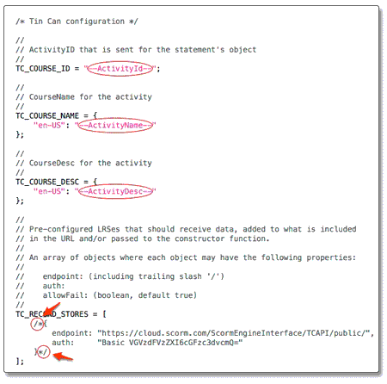
Here’s what to modify in tc-config.js (it’s largely similar to how you updated tincan.xml):
- --ActivityID-- : This is the object of the Tin Can statement. It’s usually a URL. You can use whatever you want here, just make it something that makes your activity uniquely identifiable.
- --ActivityName-- : Replace this with the title of your course or activity.
- --ActivityDesc-- : Replace this with a very brief description of your activity.
Now, the current configuration will allow you to create a a Tin Can package that will send statements to the LRS of whichever Tin Can enabled LMS you import it into. However, you have the option of sending statements to more than one LRS at a time. To demonstrate this, look for the two tiny circles in the screenshot above. Just delete the /* and the */ in the bottom of the tc-config.js, and when you launch your Tin Can course, you’ll be generating statements to your LMS as well as to our public LRS. Make sure to check our public LRS after you’ve generated statements in this way. You can see your statements in your LMS and in our public LRS.
If you don’t delete the /* and */ as mentioned above, you’ll only generate statements to the LRS of the LMS that you imported your content to.
After you’ve made your modifications, save your file and move on to the next step.
3. Insert Content
This process is the same for AICC and all versions of SCORM. You should already have your course created — your HTML, your movies, images, whatever you have. Take all of the files that comprise your course, and drop them in the “scormcontent” folder inside the SCORM Driver file system. Note what the file name is for the first page of your course- you’ll need it for the next step.
NOTE: you shouldn’t drop just one folder that contains your files into the “scormcontent” folder, you should drop your actual HTML and content files into the “scormcontent” folder.
Ack! I don’t have any content to test with!
We have a sample course that has zero SCORM/AICC conformance, and you can download it here.


4. Match Your Course’s File Name in indexAPI.html
Find the indexAPI.html file in the scormdriver folder. Open it in your text editor, and find the code that you see here:
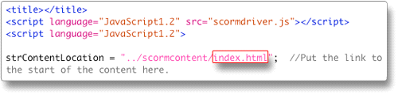
The only thing that you want to change in this file is “index.html”. Look back at the files you just copied into the “scormcontent” folder, and note the file name of the first page of your course. Change “index.html” inside the indexAPI.html file to that file name. If the file name is “training1.html” in your “scormcontent” folder, then just replace the text “index.html” with the text “training1.html”. It’s important for your file name to not have any spaces in it.
Note: this is different from the “course title” that you changed in your “imsmanifest.xml” file or your “yourcourse.crs” file. This is the actual name of the first file in your course. To double check, look back in the “scormcontent” folder and see the file name of the first file in your course.
Re-save your file.
Your course is now technically SCORM, Tin Can API, or AICC (whichever you chose) conformant! We don’t want to stop here, though. We should add bookmarking and completion to your course. It’s easy to do…just hit the “next” button.

5. Add Extras (bookmarking, completion, etc.)
If you know basic HTML, then this step will be a breeze for you. If not, then we’ll try to make it as easy as possible for you.
Bookmarking Code
You’ll need to add some bookmarking code to the pages of your course so that a learner’s location within your course can be tracked and recalled.
Go back to the “scormcontent” folder from the root of the Driver folder, and find all of the HTML files that are a part of your course. Open the first HTML file of your course with your text editor, and you should see lots of HTML code.
Look for the closing HEAD tag. Note: there are two HEAD tags. The opening HEAD tag has no “/” in it. The closing HEAD tag has a “/” in it.
It should look like this:

Once you’ve found the closing HEAD tag, you need to paste the bookmarking code just above that tag. Here’s the bookmarking code to copy/paste into your file:

If you did it correctly, your final code should look something like this:
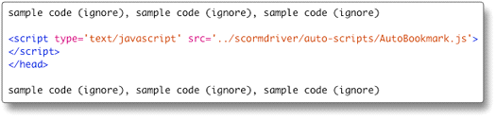
Re-save your file, and you’ve now added bookmarking to that page. Repeat the process for every HTML page that’s a part of your course. Now you’re ready to add completion code.
Completion Code
This is very similar to adding bookmarking code, except completion code is only added to the very last page of your course — the page that says something like “Congratulations, you’re done!”
You’ll add this completion code directly above the bookmarking code that should already be in place (copy/paste this):

So, the final code on your “completed” page should look like this:
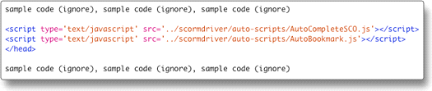
Re-save this last file, and you’re done with this step.
Others
If you want to add other SCORM functionality to your course, there’s plenty that can be done. It’s a fair assumption that if you know that you want to add more, then you probably have a decent understanding of HTML and javascript (at least we’re going to assume that.) You can find all of the other SCORM functions that can be added to your course in the more detailedSCORM HYPERLINK "https://docs.google.com/document/pub?id=1B3l5ptlBWjOezXXtCTfYK_kH6mxvR7o0fjGRzIT3z5s" Driver documentation.

Dans les fichiers HTML du document fait ((dans scorm content) tous ou dernier pour complete).......
<script type='text/javascript' src='../scormdriver/auto-scripts/AutoCompleteSCO.js'></script>
<script type='text/javascript' src='../scormdriver/auto-scripts/AutoBookmark.js'></script>
<script type='text/javascript' src='../scormdriver/auto-scripts/CourseExit.js'></script>
<script type='text/javascript' src='../scormdriver/scormdriver.js'></script>
<script type='text/javascript' src='../scormdriver/browsersniff.js'></script>

</head>

dans le fichier java script (fait sous flash) posé(dans scorm content)au momment ou le jeux est fini

SCORM_SetScore(scoredujeu, scoremaxi, scoremini);
SCORM_Finish();

Zipper les fichiers de manière a ce que immanifest soit à la racine du dossier zip

Dans les parametres scorm moodle
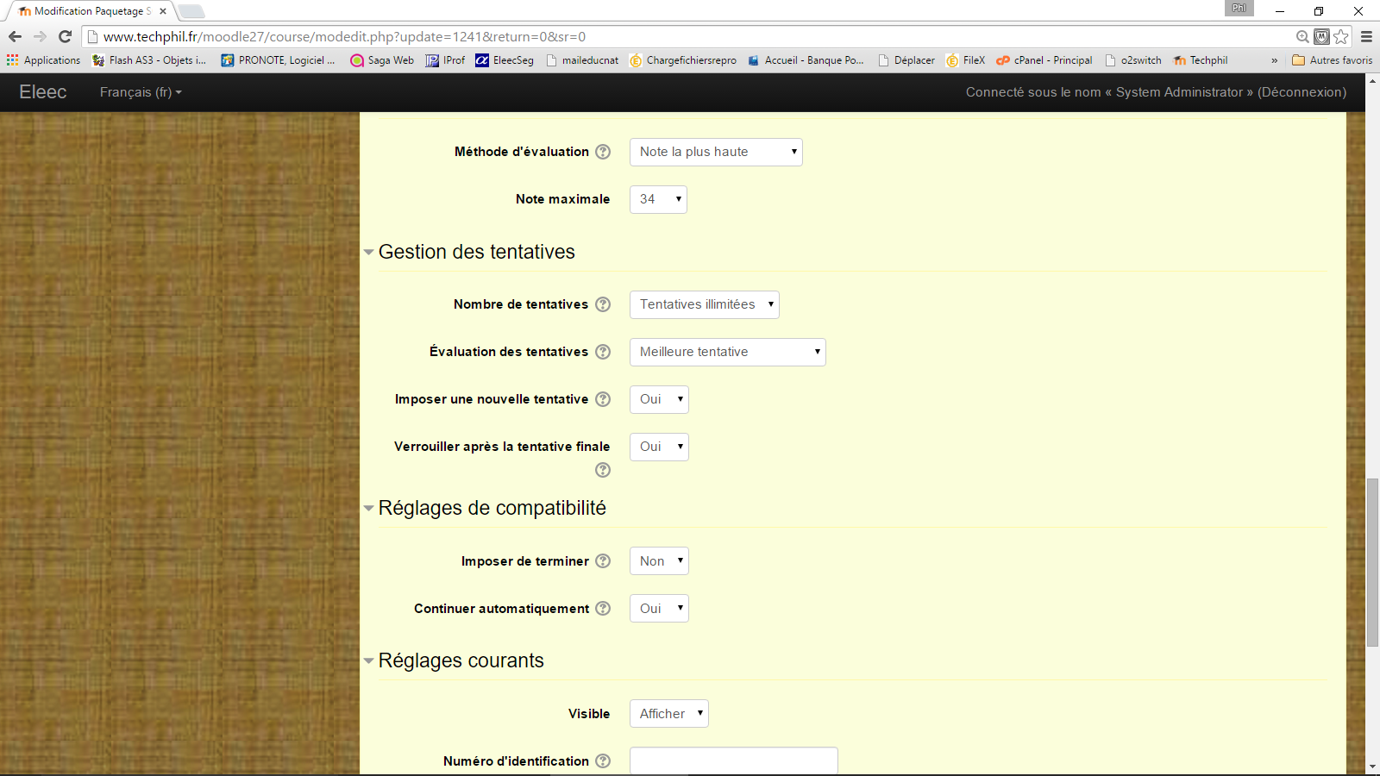

<file href="scormcontent/demarDirect5.html" />
<file href="scormcontent/images/balai.png" />
<file href="scormcontent/images/baretteMot.png" />
<file href="scormcontent/images/Bitmap14.png" />
<file href="scormcontent/images/Bitmap15.png" />
<file href="scormcontent/images/Bitmap16.png" />
<file href="scormcontent/images/bonhomBeige.png" />
<file href="scormcontent/images/bonhombleu.png" />
<file href="scormcontent/images/bonhomNoir.png" />
<file href="scormcontent/images/bonhomrouge.png" />
<file href="scormcontent/images/bonhomvert.png" />
<file href="scormcontent/images/Bornier.png" />
<file href="scormcontent/images/fil_beige.png" />
<file href="scormcontent/images/fil_bleu.png" />
<file href="scormcontent/images/fil_noir.png" />
<file href="scormcontent/images/fil_rouge.png" />
<file href="scormcontent/images/fil_VertJaune.png" />
<file href="scormcontent/images/logotechphil.png" />
<file href="scormcontent/images/Moteur.png" />
<file href="scormcontent/images/platine.png" />
<file href="scormcontent/images/platineCoffret.png" />
<file href="scormcontent/images/Port1.png" />
<file href="scormcontent/images/port2.png" />
<file href="scormcontent/images/port3.png" />
<file href="scormcontent/images/port4.png" />
<file href="scormcontent/images/port5.png" />
<file href="scormcontent/images/port6.png" />
<file href="scormcontent/images/Porte fermée.png" />
<file href="scormcontent/images/PorteOuverte.png" />
<file href="scormcontent/images/taches.png" />
<file href="scormcontent/images/schema DD.png" />
<file href="scormcontent/images/thermique.png" />

